# **Name: Abdurrahman Qureshi**

# **Roll No: 210451**

Practical No: 11

**1) Write a Program to show five checkboxes and toast selected checkbox.**

**XML CODE:**

<?xml version="1.0" encoding="utf-8"?>  
<LinearLayout xmlns:android="http://schemas.android.com/apk/res/android"  
 xmlns:app="http://schemas.android.com/apk/res-auto"  
 xmlns:tools="http://schemas.android.com/tools"  
 android:layout_width="match_parent"  
 android:layout_height="match_parent"  
 android:orientation="vertical"  
 android:padding="10dp"  
 tools:context=".MainActivity">  
 <CheckBox  
 android:id="@+id/cb1"  
 android:layout_width="wrap_content"  
 android:layout_height="wrap_content"  
 android:text="This is a checkbox."  
 android:layout_margin="15dp"  
 android:textSize="30sp"  
 android:onClick="onCheckBoxClicked"/>  
 <CheckBox  
 android:id="@+id/cb2"  
 android:layout_width="wrap_content"  
 android:layout_height="wrap_content"  
 android:text="This is also a checkbox."  
 android:layout_margin="15dp"  
 android:textSize="30sp"  
 android:onClick="onCheckBoxClicked"/>  
 <CheckBox  
 android:id="@+id/cb3"  
 android:layout_width="wrap_content"  
 android:layout_height="wrap_content"  
 android:text="Already said, this is a checkbox."  
 android:layout_margin="15dp"  
 android:textSize="30sp"  
 android:onClick="onCheckBoxClicked"/>  
 <CheckBox  
 android:id="@+id/cb4"  
 android:layout_width="wrap_content"  
 android:layout_height="wrap_content"  
 android:text="Have you not understood? This is a checkbox."  
 android:layout_margin="15dp"  
 android:textSize="30sp"  
 android:onClick="onCheckBoxClicked"/>  
 <CheckBox  
 android:id="@+id/cb5"  
 android:layout_width="wrap_content"  
 android:layout_height="wrap_content"  
 android:text="Okay I give up."  
 android:layout_margin="15dp"  
 android:textSize="30sp"  
 android:onClick="onCheckBoxClicked"/>  
 <Button  
 android:id="@+id/btn1"  
 android:layout_width="wrap_content"  
 android:layout_height="wrap_content"  
 android:text="Get Selected Checkboxes"  
 android:layout_gravity="bottom|center"/>  
</LinearLayout>

**JAVA CODE:**

package com.example.madprac11;  
  
import androidx.appcompat.app.AppCompatActivity;  
  
import android.os.Bundle;  
import android.view.View;  
import android.widget.Button;  
import android.widget.CheckBox;  
import android.widget.Toast;  
  
public class MainActivity extends AppCompatActivity {  
  
 @Override  
 protected void onCreate(Bundle savedInstanceState) {  
 super.onCreate(savedInstanceState);  
 setContentView(R.layout.*activity_main*);  
  
 CheckBox checkBox1 = (CheckBox) findViewById(R.id.*cb1*);  
 CheckBox checkBox2 = (CheckBox) findViewById(R.id.*cb2*);  
 CheckBox checkBox3 = (CheckBox) findViewById(R.id.*cb3*);  
 CheckBox checkBox4 = (CheckBox) findViewById(R.id.*cb4*);  
 CheckBox checkBox5 = (CheckBox) findViewById(R.id.*cb5*);  
 Button button = (Button) findViewById(R.id.*btn1*);  
  
 button.setOnClickListener(new View.OnClickListener() {  
 @Override  
 public void onClick(View view) {  
 int selectedCheckBoxCount = 0;  
 if(checkBox1.isChecked())  
 selectedCheckBoxCount++;  
 if(checkBox2.isChecked())  
 selectedCheckBoxCount++;  
 if(checkBox3.isChecked())  
 selectedCheckBoxCount++;  
 if(checkBox4.isChecked())  
 selectedCheckBoxCount++;  
 if(checkBox5.isChecked())  
 selectedCheckBoxCount++;  
 Toast.*makeText*(getApplicationContext(), "Number of selected checkboxes: " + selectedCheckBoxCount, Toast.*LENGTH_SHORT*).show();}  
 });}  
 public void onCheckBoxClicked(View view{  
 String result;  
 boolean selected = ((CheckBox)view).isChecked();  
 result = selected ? "\"" + ((CheckBox)view).getText().toString() + "\" selected." : "\"" + ((CheckBox)view).getText().toString() + "\" deselected." ;  
 Toast.*makeText*(getApplicationContext(), result, Toast.*LENGTH_SHORT*).show();}}

**OUTPUT:**

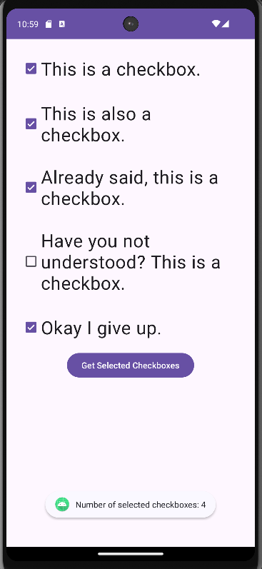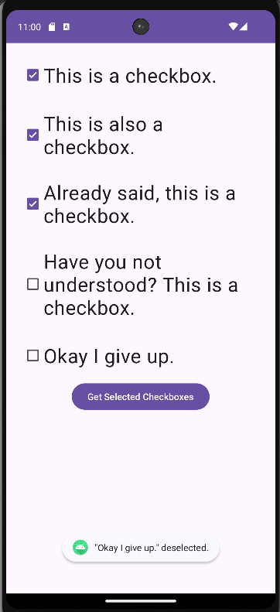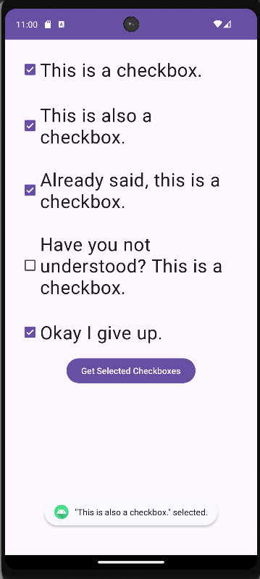

**2) Create the below form and on the selection of checkbox it should display message as Selected, when deselected it should display message as Deselected and on button click all the selected checkbox should be displayed.**

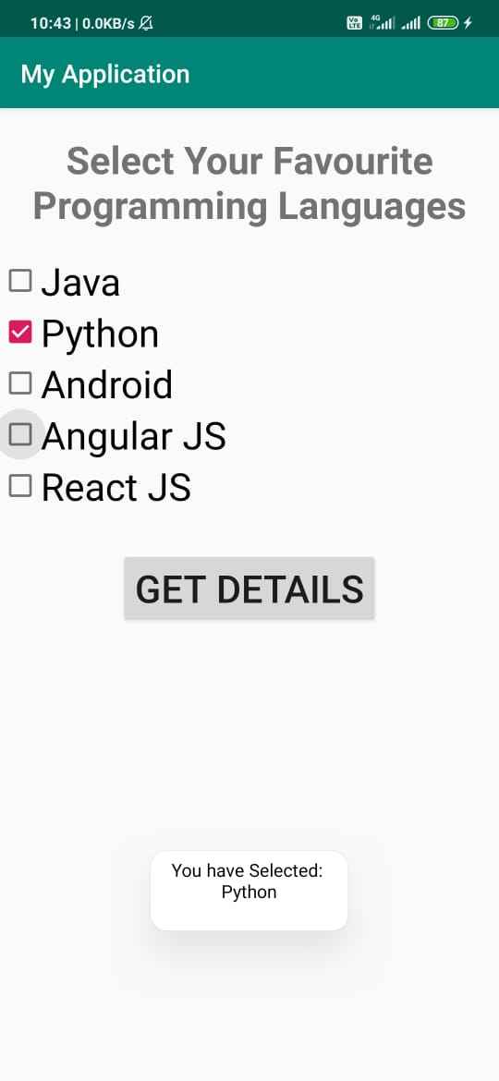

**XML CODE:**

<?xml version="1.0" encoding="utf-8"?>  
<LinearLayout xmlns:android="http://schemas.android.com/apk/res/android"  
 xmlns:app="http://schemas.android.com/apk/res-auto"  
 xmlns:tools="http://schemas.android.com/tools"  
 android:layout_width="match_parent"  
 android:layout_height="match_parent"  
 android:orientation="vertical"  
 android:padding="10dp"  
 tools:context=".MainActivity">  
  
 <TextView  
 android:layout_width="match_parent"  
 android:layout_height="wrap_content"  
 android:text="Select your favourite programming languages:"  
 android:textSize="30sp"  
 android:layout_marginVertical="15dp"  
 android:gravity="center"/>  
  
 <CheckBox  
 android:id="@+id/cb1"  
 android:layout_width="wrap_content"  
 android:layout_height="wrap_content"  
 android:text="C#"  
 android:textSize="20sp"  
 android:onClick="onCheckBoxClicked"/>  
  
 <CheckBox  
 android:id="@+id/cb2"  
 android:layout_width="wrap_content"  
 android:layout_height="wrap_content"  
 android:text="GDScript"  
 android:textSize="20sp"  
 android:onClick="onCheckBoxClicked"/>  
  
 <CheckBox  
 android:id="@+id/cb3"  
 android:layout_width="wrap_content"  
 android:layout_height="wrap_content"  
 android:text="Python"  
 android:textSize="20sp"  
 android:onClick="onCheckBoxClicked"/>  
  
 <CheckBox  
 android:id="@+id/cb4"  
 android:layout_width="wrap_content"  
 android:layout_height="wrap_content"  
 android:text="Java"  
 android:textSize="20sp"  
 android:onClick="onCheckBoxClicked"/>  
  
 <CheckBox  
 android:id="@+id/cb5"  
 android:layout_width="wrap_content"  
 android:layout_height="wrap_content"  
 android:text="JavaScript"  
 android:textSize="20sp"  
 android:onClick="onCheckBoxClicked"/>  
  
 <Button  
 android:id="@+id/btn1"  
 android:layout_width="wrap_content"  
 android:layout_height="wrap_content"  
 android:text="Get Selected Checkboxes"  
 android:textSize="15sp"  
 android:layout_gravity=”center"/>  
  
</LinearLayout>

**JAVA CODE:**

package com.example.madprac11;  
  
import androidx.appcompat.app.AppCompatActivity;  
  
import android.os.Bundle;  
import android.view.View;  
import android.widget.Button;  
import android.widget.CheckBox;  
import android.widget.Toast;  
  
public class MainActivity extends AppCompatActivity {  
  
 @Override  
 protected void onCreate(Bundle savedInstanceState) {  
 super.onCreate(savedInstanceState);  
 setContentView(R.layout.*activity_main*);  
  
 CheckBox checkBox1 = (CheckBox) findViewById(R.id.*cb1*);  
 CheckBox checkBox2 = (CheckBox) findViewById(R.id.*cb2*);  
 CheckBox checkBox3 = (CheckBox) findViewById(R.id.*cb3*);  
 CheckBox checkBox4 = (CheckBox) findViewById(R.id.*cb4*);  
 CheckBox checkBox5 = (CheckBox) findViewById(R.id.*cb5*);  
 Button button = (Button) findViewById(R.id.*btn1*);  
  
 button.setOnClickListener(new View.OnClickListener() {  
 @Override  
 public void onClick(View view) {  
 String selectedCheckBoxes = "Selected languages:\n";  
 if(checkBox1.isChecked())  
 selectedCheckBoxes += "C#\n";  
 if(checkBox2.isChecked())  
 selectedCheckBoxes += "GDScript\n";  
 if(checkBox3.isChecked())  
 selectedCheckBoxes += "Python\n";  
 if(checkBox4.isChecked())  
 selectedCheckBoxes += "Java\n";  
 if(checkBox5.isChecked())  
 selectedCheckBoxes += "JavaScript";  
  
 Toast.*makeText*(getApplicationContext(), selectedCheckBoxes, Toast.*LENGTH_SHORT*).show();  
 }  
 });  
 }  
  
 public void onCheckBoxClicked(View view) {  
 String result;  
 boolean selected = ((CheckBox)view).isChecked();  
 result = selected ? "\"" + ((CheckBox)view).getText().toString() + "\" selected." : "\"" + ((CheckBox)view).getText().toString() + "\" deselected." ;  
 Toast.*makeText*(getApplicationContext(), result, Toast.*LENGTH_SHORT*).show();  
 }  
}

**OUTPUT:**

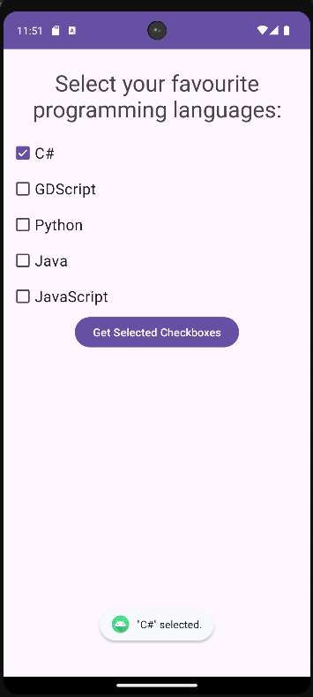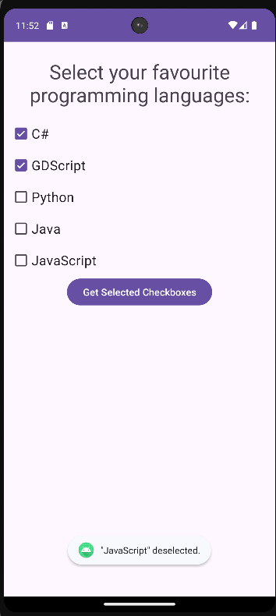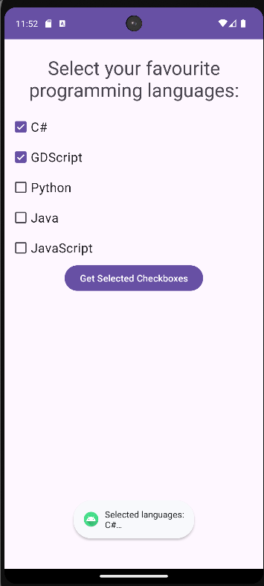

**3) Write a Program to create the below form and on the click of Ok button it should display the text of the checkbox and on Cancel button it should deselect the selected checkbox.**

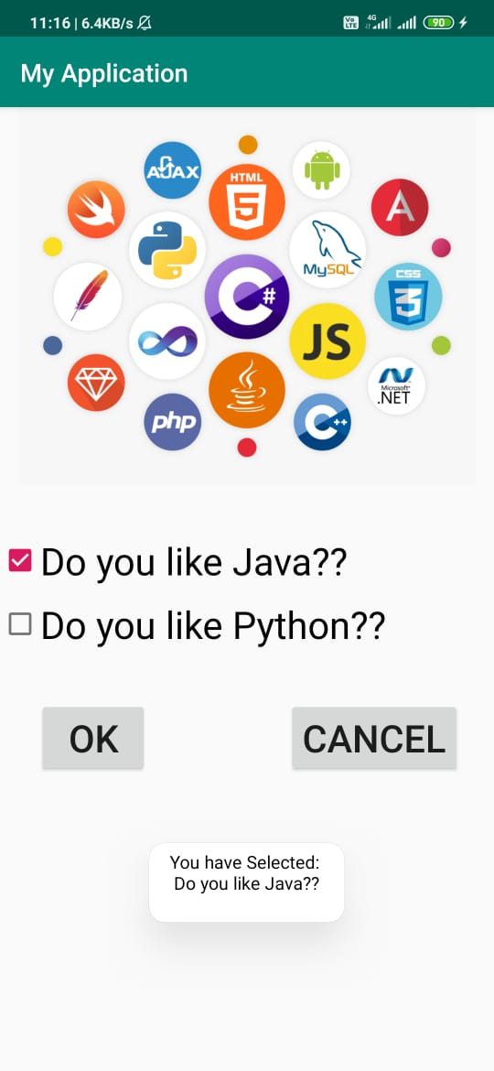

**XML CODE:**

<?xml version="1.0" encoding="utf-8"?>  
<LinearLayout xmlns:android="http://schemas.android.com/apk/res/android"  
 xmlns:app="http://schemas.android.com/apk/res-auto"  
 xmlns:tools="http://schemas.android.com/tools"  
 android:layout_width="match_parent"  
 android:layout_height="match_parent"  
 android:orientation="vertical"  
 android:padding="10dp"  
 tools:context=".MainActivity">  
  
 <ImageView  
 android:layout_width="394dp"  
 android:layout_height="282dp"  
 android:src="@drawable/langs"/>  
  
 <CheckBox  
 android:id="@+id/cb1"  
 android:layout_width="wrap_content"  
 android:layout_height="wrap_content"  
 android:text="Do you like Java?"  
 android:textSize="20sp"/>  
  
 <CheckBox  
 android:id="@+id/cb2"  
 android:layout_width="wrap_content"  
 android:layout_height="wrap_content"  
 android:text="Do you like Python?"  
 android:textSize="20sp"/>  
  
 <LinearLayout  
 android:layout_width="match_parent"  
 android:layout_height="wrap_content"  
 android:layout_marginVertical="25dp"  
 android:gravity="center">  
  
 <Button  
 android:id="@+id/btn1"  
 android:layout_width="wrap_content"  
 android:layout_height="wrap_content"  
 android:text="OK"  
 android:textSize="15sp"  
 android:layout_gravity="bottom|center"/>  
  
 <View  
 android:layout_width="115dp"  
 android:layout_height="0dp"/>  
  
 <Button  
 android:id="@+id/btn2"  
 android:layout_width="wrap_content"  
 android:layout_height="wrap_content"  
 android:text="Cancel"  
 android:textSize="15sp"  
 android:layout_gravity="bottom|center"/>  
  
 </LinearLayout>

**JAVA CODE:**

package com.example.madprac11;  
  
import androidx.appcompat.app.AppCompatActivity;  
  
import android.os.Bundle;  
import android.view.View;  
import android.widget.Button;  
import android.widget.CheckBox;  
import android.widget.Toast;  
  
public class MainActivity extends AppCompatActivity {  
  
 @Override  
 protected void onCreate(Bundle savedInstanceState) {  
 super.onCreate(savedInstanceState);  
 setContentView(R.layout.*activity_main*);  
  
 CheckBox checkBox1 = (CheckBox) findViewById(R.id.*cb1*);  
 CheckBox checkBox2 = (CheckBox) findViewById(R.id.*cb2*);  
 Button button1 = (Button) findViewById(R.id.*btn1*);  
 Button button2 = (Button) findViewById(R.id.*btn2*);  
  
 button1.setOnClickListener(new View.OnClickListener() {  
 @Override  
 public void onClick(View view) {  
 String result;  
 if(checkBox1.isChecked() || checkBox2.isChecked()) {  
 result = "You have selected ";  
 result += checkBox1.isChecked() ? "\n" + checkBox1.getText().toString() : "";  
 result += checkBox2.isChecked() ? "\n" + checkBox2.getText().toString() : "";  
 } else {  
 result = "Nothing selected.";  
 }  
 Toast.*makeText*(getApplicationContext(), result, Toast.*LENGTH_SHORT*).show();  
 }  
 });  
  
 button2.setOnClickListener(new View.OnClickListener() {  
 @Override  
 public void onClick(View view) {  
 checkBox1.setChecked(false);  
 checkBox2.setChecked(false);  
 }  
 });  
 }  
}

**OUTPUT:**

